Hibernate Overview

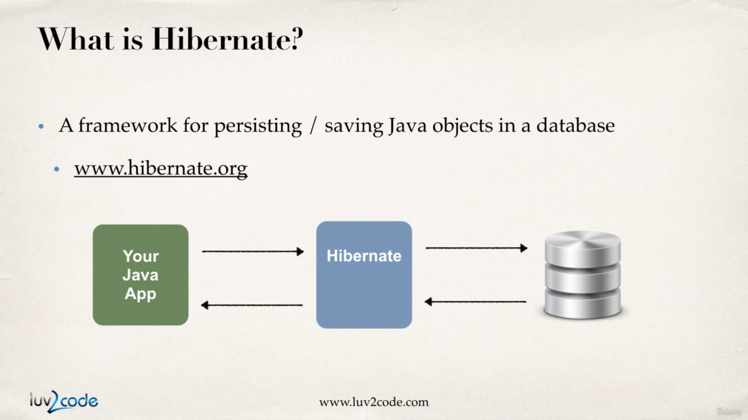

Hibernate is a very popular framework works for storing/retrieving data from the database.

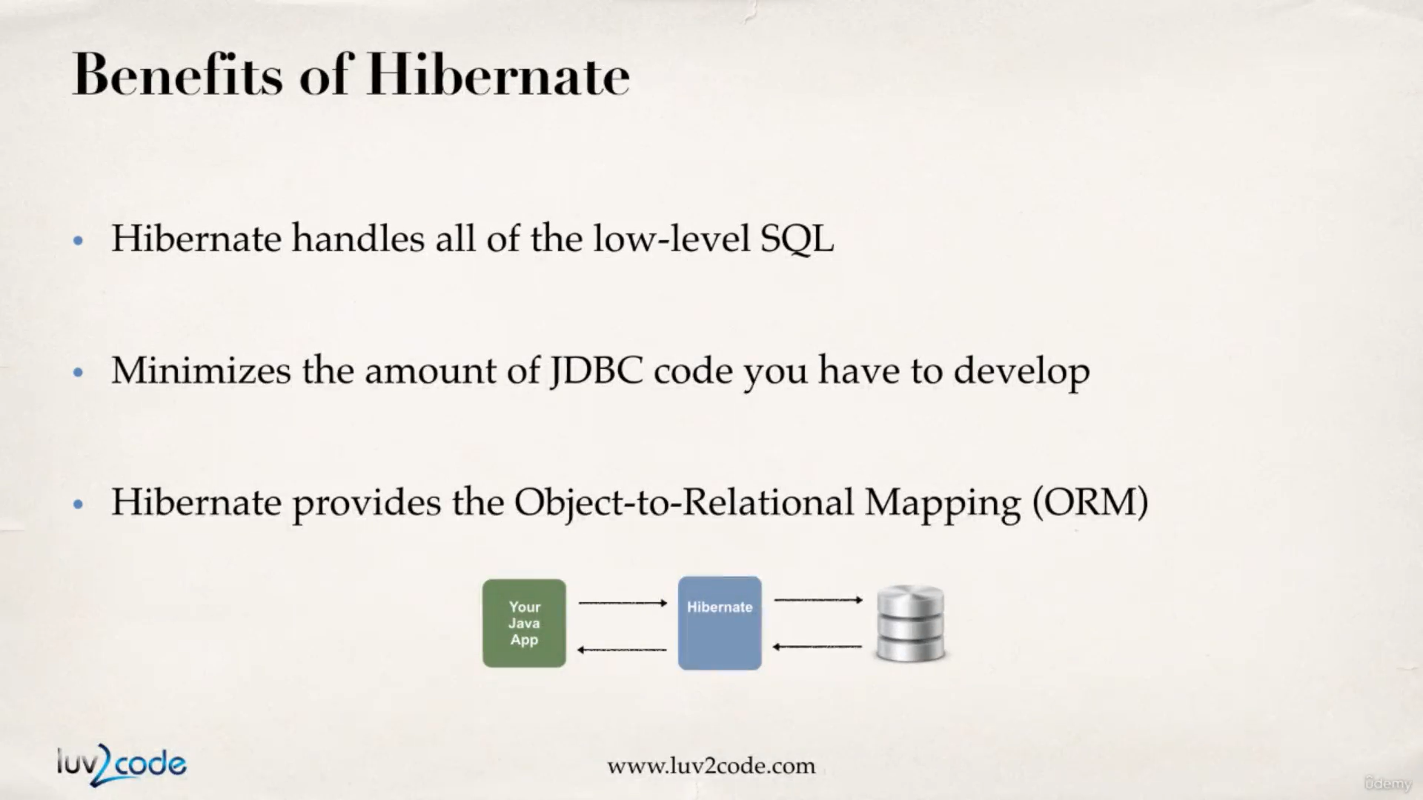

Hibernate user ORM (object-to-relational mapping) where we tell hibernate how to map our java objects to the database table. Under the hood all the properties in the java object will be mapped to actual column names.

This ORM config can be done with the help of an XML file or with the help of annotations.

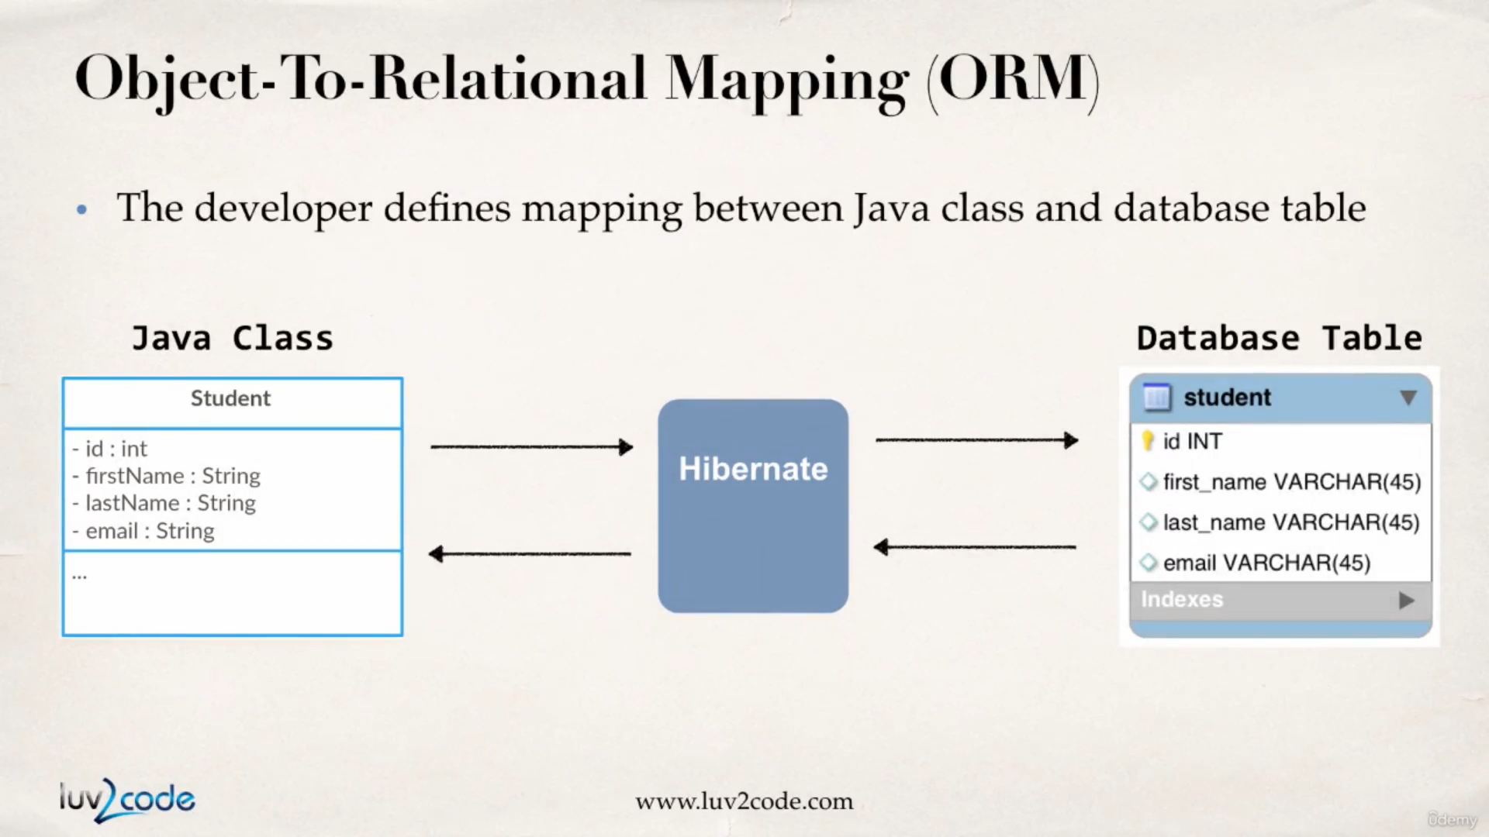

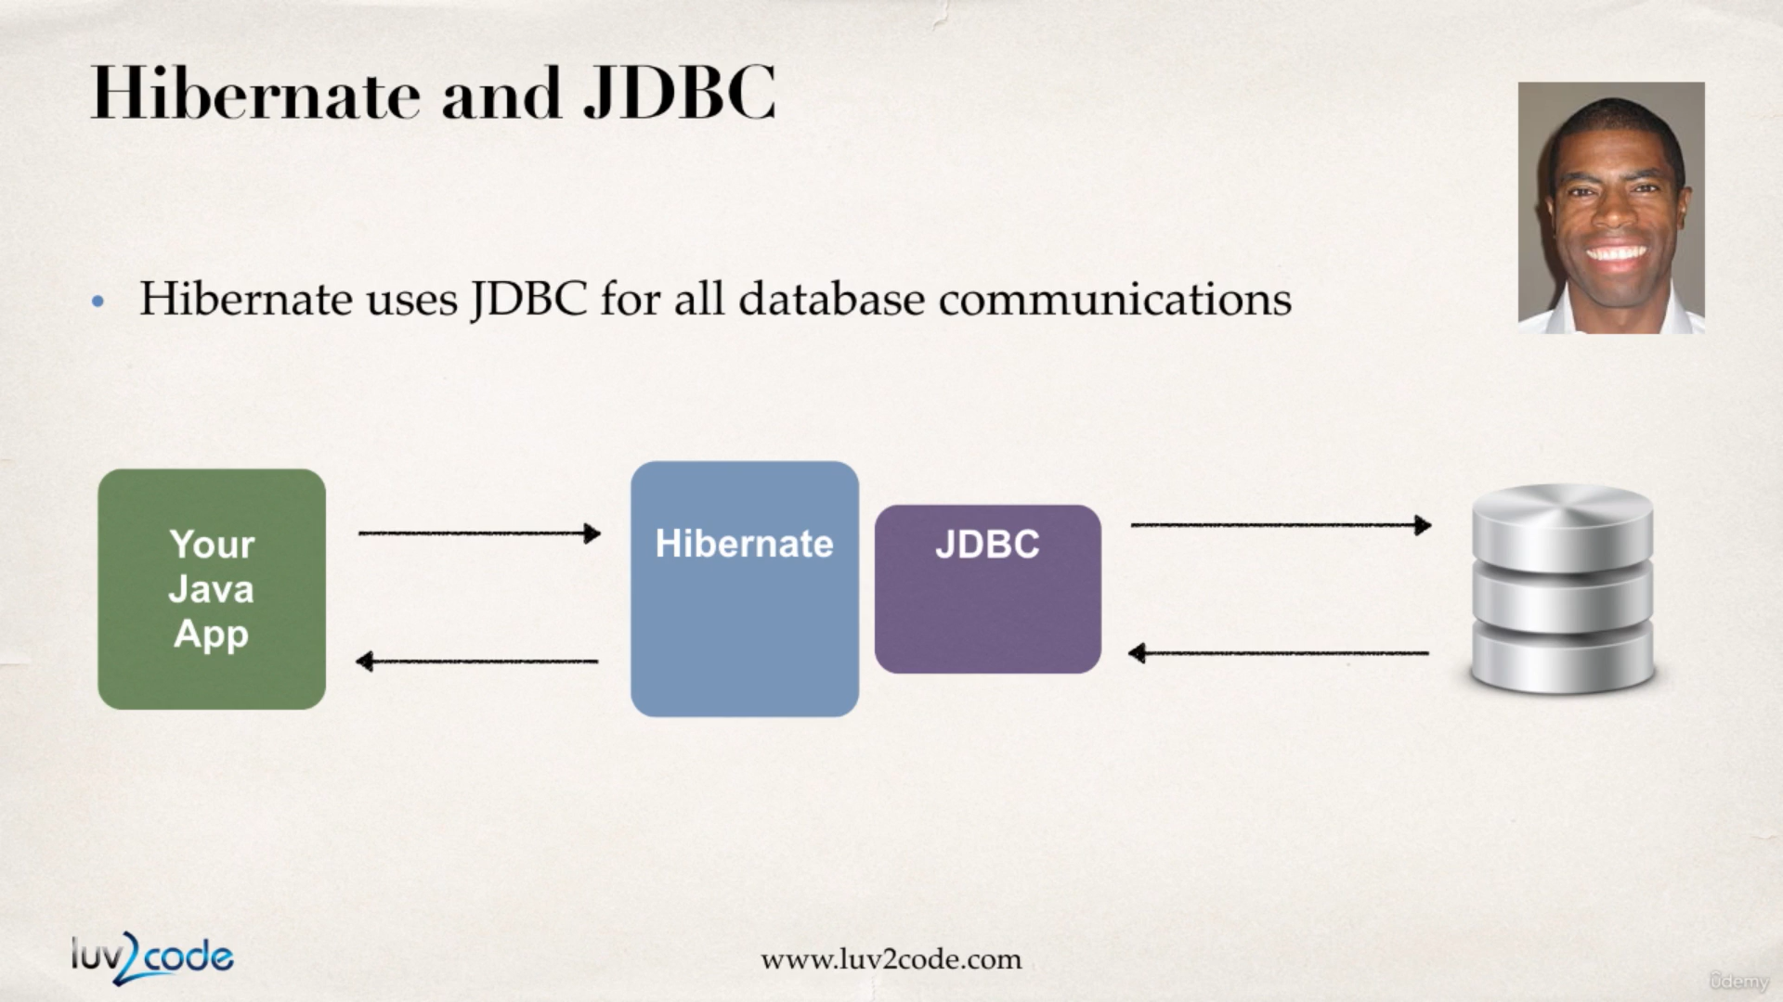

Hibernate is just another layer of abstraction on the top of JDBC.

This course uses Hibernate 5.2 and Hibernate 5.2 requires Java 8.

We can test the connection to the data base by writing a small jdbc class :

TestJdbc.java :

**package** com.hibernate.jdbc;

**import** java.sql.Connection;

**import** java.sql.DriverManager;

**public** **class** TestJdbc {

**public** **static** **void** main(String[] args) {

**final** String url = "jdbc:mysql://localhost:3306/hb_student_tracker?useSSL=false&serverTimeZone=UTC";

**final** String username = "hbstudent";

**final** String password = "hbstudent";

**try** {

System.***out***.println("connecting to database : " + url);

Connection connection = DriverManager.*getConnection*(url, username, password);

System.***out***.println("connection established");

} **catch** (Exception e) {

e.printStackTrace();

}

}

}

output :

connecting to database : jdbc:mysql://localhost:3306/hb_student_tracker?useSSL=false&serverTimeZone=UTC

connection established

Hibernate Configurations with Annotations

The hibernate configuration file is going to tell hibernate how to connect to the database. Also as we know previously, Hibernate uses JDBC for establishing connection.

Have a look at the sample hibernate config xml file :

<!DOCTYPE hibernate-configuration PUBLIC

"-//Hibernate/Hibernate Configuration DTD 3.0//EN"

"http://www.hibernate.org/dtd/hibernate-configuration-3.0.dtd">

<hibernate-configuration>

<session-factory>

<!-- JDBC Database connection settings -->

<property name=*"connection.driver_class"*>com.mysql.cj.jdbc.Driver</property>

<property name=*"connection.url"*>jdbc:mysql://localhost:3306/hb_student_tracker?useSSL=false&amp;serverTimezone=UTC</property>

<property name=*"connection.username"*>hbstudent</property>

<property name=*"connection.password"*>hbstudent</property>

<!-- JDBC connection pool settings ... using built-in test pool -->

<property name=*"connection.pool_size"*>1</property>

<!-- Select our SQL dialect -->

<property name=*"dialect"*>org.hibernate.dialect.MySQLDialect</property>

<!-- Echo the SQL to stdout -->

<property name=*"show_sql"*>true</property>

<!-- Set the current session context -->

<property name=*"current_session_context_class"*>thread</property>

</session-factory>

</hibernate-configuration>

Hibernate has a class of Entity Class which is class mapped to database table. Well, when a POJO class is annotated it becomes an Entity class.

Now We have to

1. map a class to the database table.

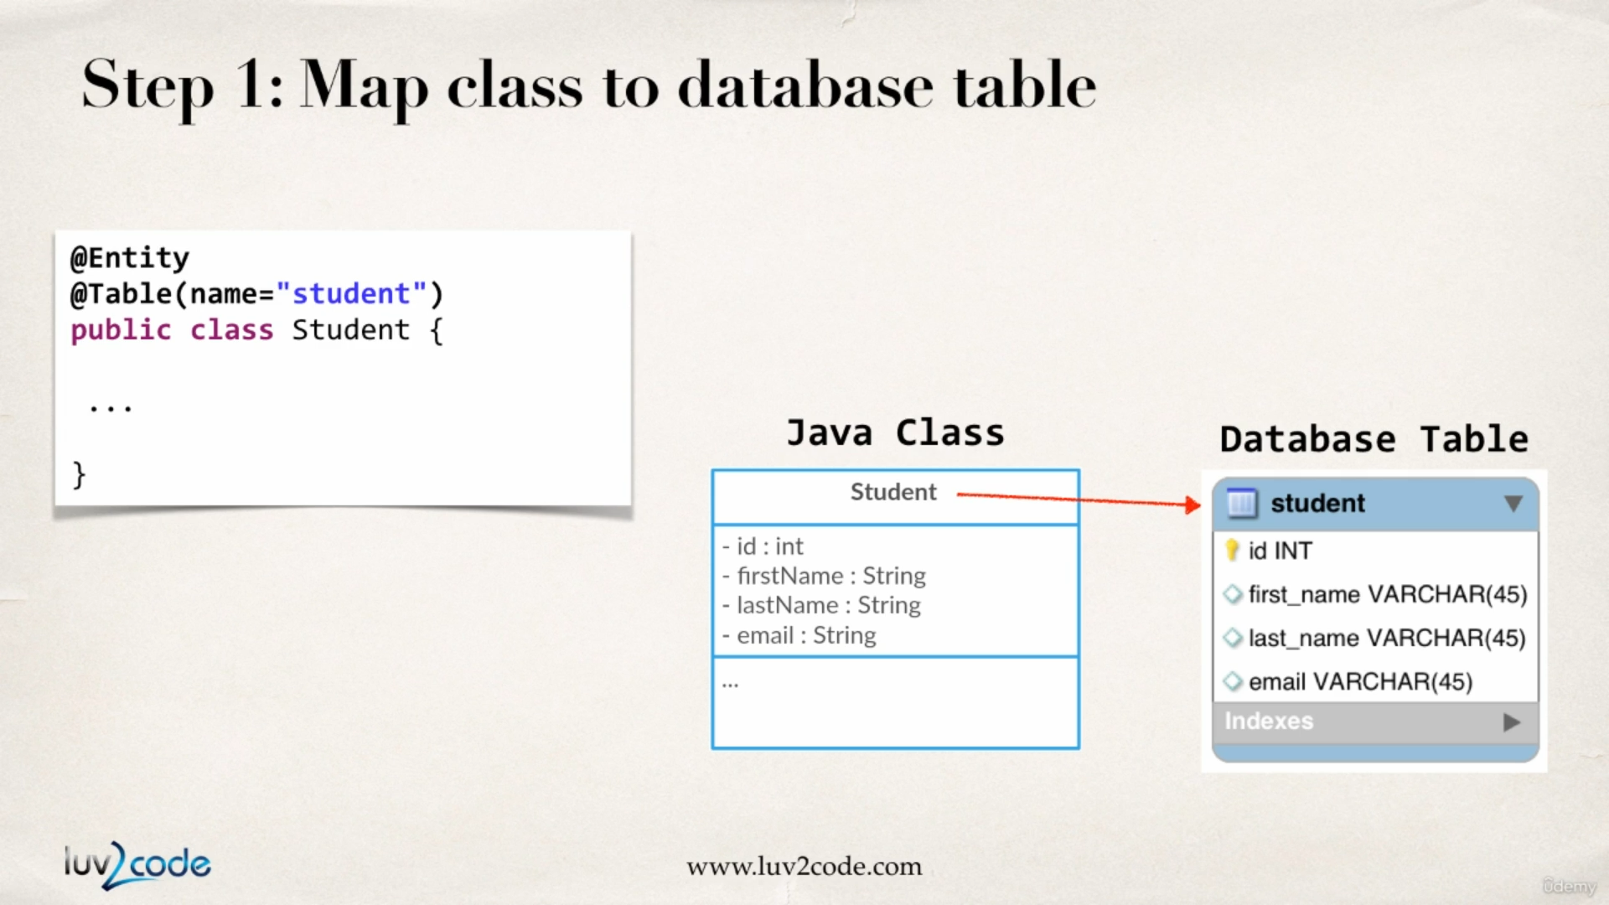

1. map the class field names to database columns.

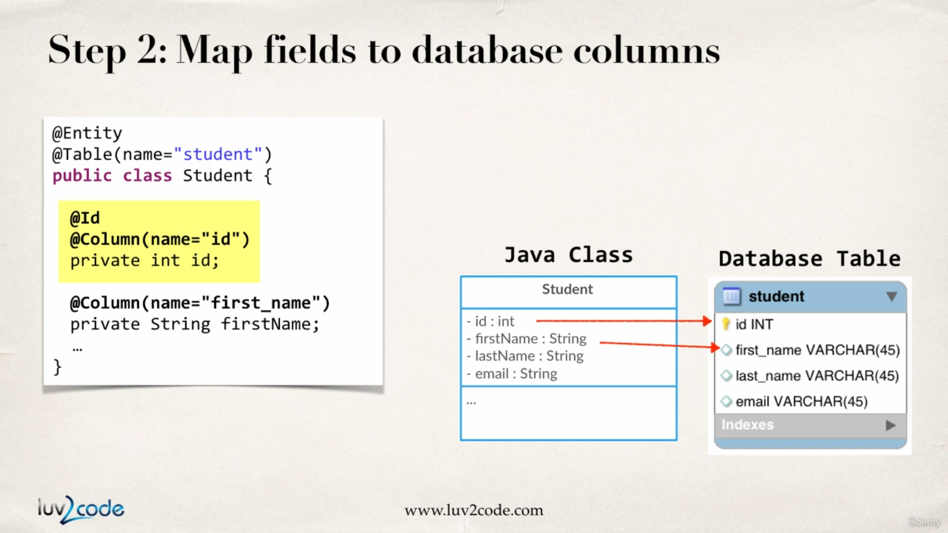

These above mapping can be done with the help of,

1. XML config files (legacy approach)
2. java annotation approach (modern approach)

First of all we will create a Student class and from inside the class we will annotate the fields so that they get connected to the db table.

Student.java :

**package** com.hibernate.demo.entity;

**import** javax.persistence.Column;

**import** javax.persistence.Entity;

**import** javax.persistence.Id;

**import** javax.persistence.Table;

@Entity

@Table(name = "student")

**public** **class** Student {

@Id

@Column(name = "id")

**private** **int** id;

@Column(name = "first_name")

**private** String firstName;

@Column(name = "last_name")

**private** String lastName;

@Column(name = "email")

**private** String email;

**public** Student() {

**super**();

}

**public** Student(String firstName, String lastName, String email) {

**super**();

**this**.firstName = firstName;

**this**.lastName = lastName;

**this**.email = email;

}

**public** **int** getId() {

**return** id;

}

**public** **void** setId(**int** id) {

**this**.id = id;

}

**public** String getFirstName() {

**return** firstName;

}

**public** **void** setFirstName(String firstName) {

**this**.firstName = firstName;

}

**public** String getLastName() {

**return** lastName;

}

**public** **void** setLastName(String lastName) {

**this**.lastName = lastName;

}

**public** String getEmail() {

**return** email;

}

**public** **void** setEmail(String email) {

**this**.email = email;

}

@Override

**public** String toString() {

**return** "Student [id=" + id + ", firstName=" + firstName + ", lastName=" + lastName + ", email=" + email + "]";

}

}

Saving a Java Object with Hibernate

**SessionFactory** : This is the person who reads the hibernate config file, creates a connection to the database, creates session object for us. This is a heavy weight object, we only create it once in our application but we re use it over and over again.

**Session :** This is a wrapper around our JDBC connection. This session object will be used to save and retrieve object to/from the database. Session is a short lived method, for a given method we get a session, we use it and we throw it away(we will see how). Sessions are retrieved from the session factory.

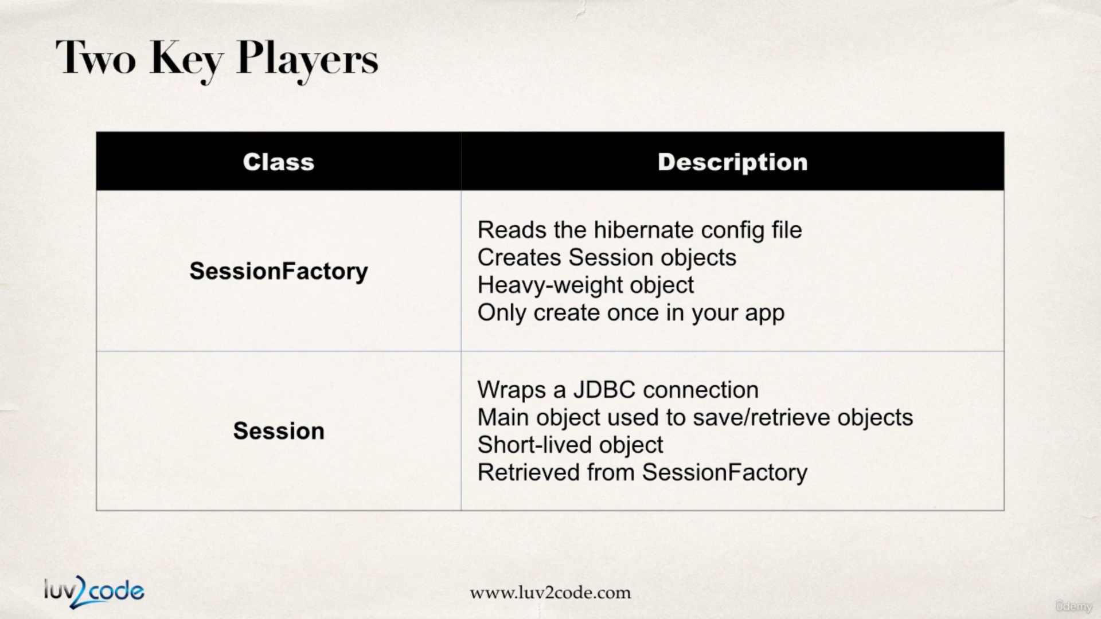

Previously we had created a student Entity class and had that mapped with the database with the help of hibernate annotations.

Student.java :

**package** com.hibernate.demo.entity;

**import** javax.persistence.Column;

**import** javax.persistence.Entity;

**import** javax.persistence.Id;

**import** javax.persistence.Table;

@Entity

@Table(name = "student")

**public** **class** Student {

@Id

@Column(name = "id")

**private** **int** id;

@Column(name = "first_name")

**private** String firstName;

@Column(name = "last_name")

**private** String lastName;

@Column(name = "email")

**private** String email;

**public** Student() {

**super**();

}

**public** Student(String firstName, String lastName, String email) {

**super**();

**this**.firstName = firstName;

**this**.lastName = lastName;

**this**.email = email;

}

**public** **int** getId() {

**return** id;

}

**public** **void** setId(**int** id) {

**this**.id = id;

}

**public** String getFirstName() {

**return** firstName;

}

**public** **void** setFirstName(String firstName) {

**this**.firstName = firstName;

}

**public** String getLastName() {

**return** lastName;

}

**public** **void** setLastName(String lastName) {

**this**.lastName = lastName;

}

**public** String getEmail() {

**return** email;

}

**public** **void** setEmail(String email) {

**this**.email = email;

}

@Override

**public** String toString() {

**return** "Student [id=" + id + ", firstName=" + firstName + ", lastName=" + lastName + ", email=" + email + "]";

}

}

CreateStudentDemo.java :

**package** com.hibernate.demo.second;

**import** org.hibernate.Session;

**import** org.hibernate.SessionFactory;

**import** org.hibernate.cfg.Configuration;

**import** com.hibernate.demo.entity.Student;

**public** **class** CreateStudentDemo {

**public** **static** **void** main(String[] args) {

// create session factory

SessionFactory sessionFactory = **new** Configuration()

// providing a file name is opt. hibernate will look for "hibernate.cfg.xml" as a default file name

.configure("hibernate.cfg.xml").addAnnotatedClass(Student.**class**).buildSessionFactory();

// create a session

Session currentSession = sessionFactory.getCurrentSession();

**try** {

// create student object

System.***out***.println("creating student object");

Student student = **new** Student("Anupam", "Acharya", "anupam@gmail.com");

// begin a transaction

System.***out***.println("beginning a transaction");

currentSession.beginTransaction();

// save the student object

System.***out***.println("saving the student object");

currentSession.save(student);

// commit the transaction

System.***out***.println("committing the transaction");

currentSession.getTransaction().commit();

System.***out***.println("done !!!");

} **finally** {

sessionFactory.close();

}

}

}

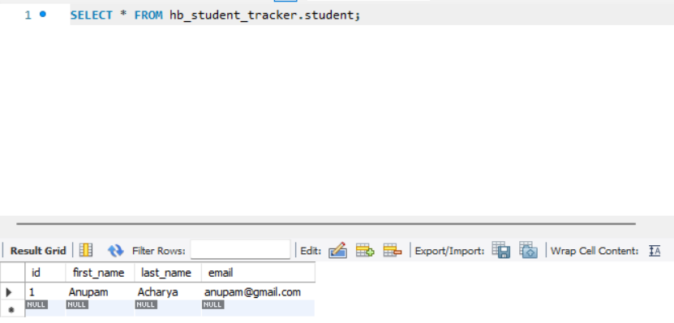

Also, the same we can verify from the database that our student object was stored.

**QUESTION:**Why we are using JPA Annotation instead of Hibernate ?

For example, why we are not using this org.hibernate.annotations.Entity?

**ANSWER:**JPA is a standard specification. Hibernate is an implementation of the JPA specification.

Hibernate implements all of the JPA annotations.

The Hibernate team recommends the use of JPA annotations as a best practice

Hibernate & Primary keys

Primary key uniquely identifies each row in a table. This must be a unique value and must not be null.

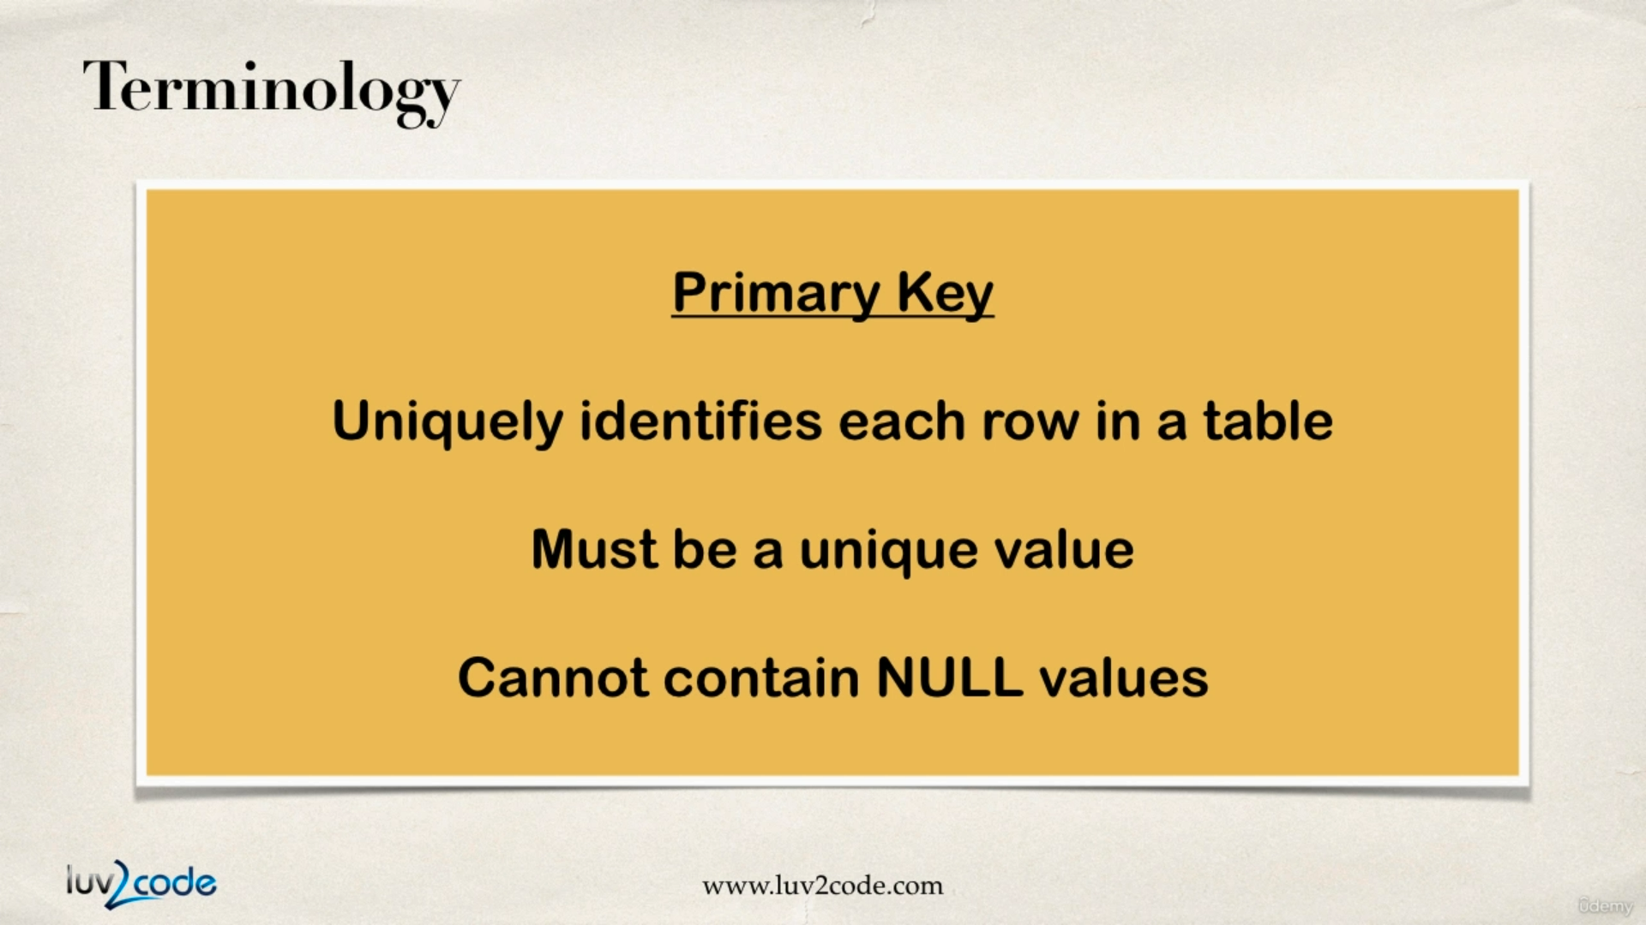

Previously while generating the Entity class we made use of **@Id** annotation which way we told hibernate it is going to be a primary key.

Now while storing objects into the database we don’t give any value for the Id column and by default for every generated entry in the database the primary key is incremented by one.

How ever there are ways in which we will be able to generate custom unique primary keys while storing data into the database. This is done with the help of **@GeneratedValue** attribute. As a value to this attribute we can now pass in the id generation strategy types.

With **GenerationType.IDENTITY** we are telling mysql to take care of the primary key ID generation process.

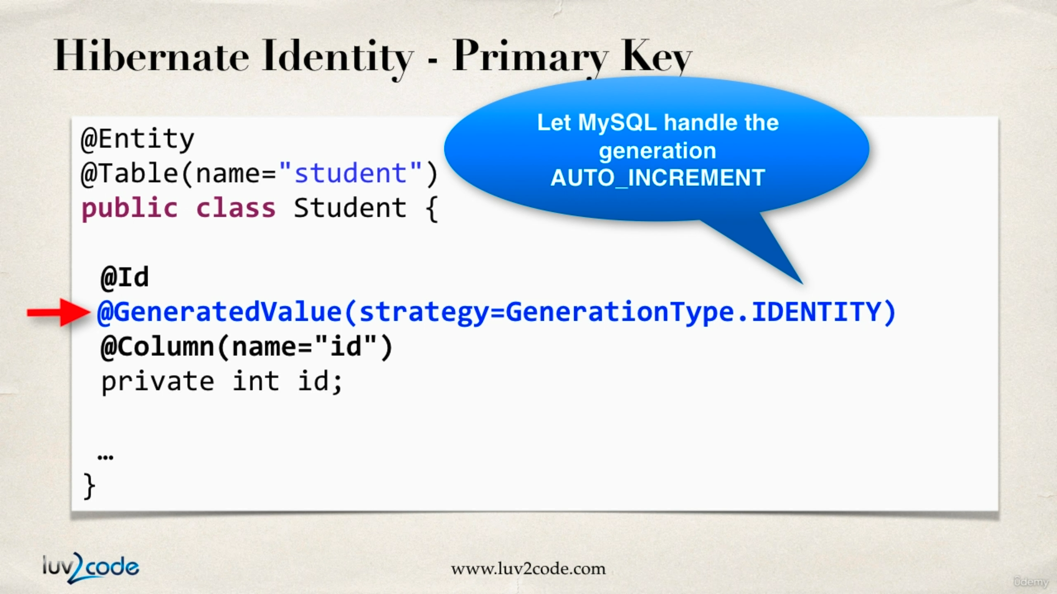

Various types of ID Generation Strategies across databases.

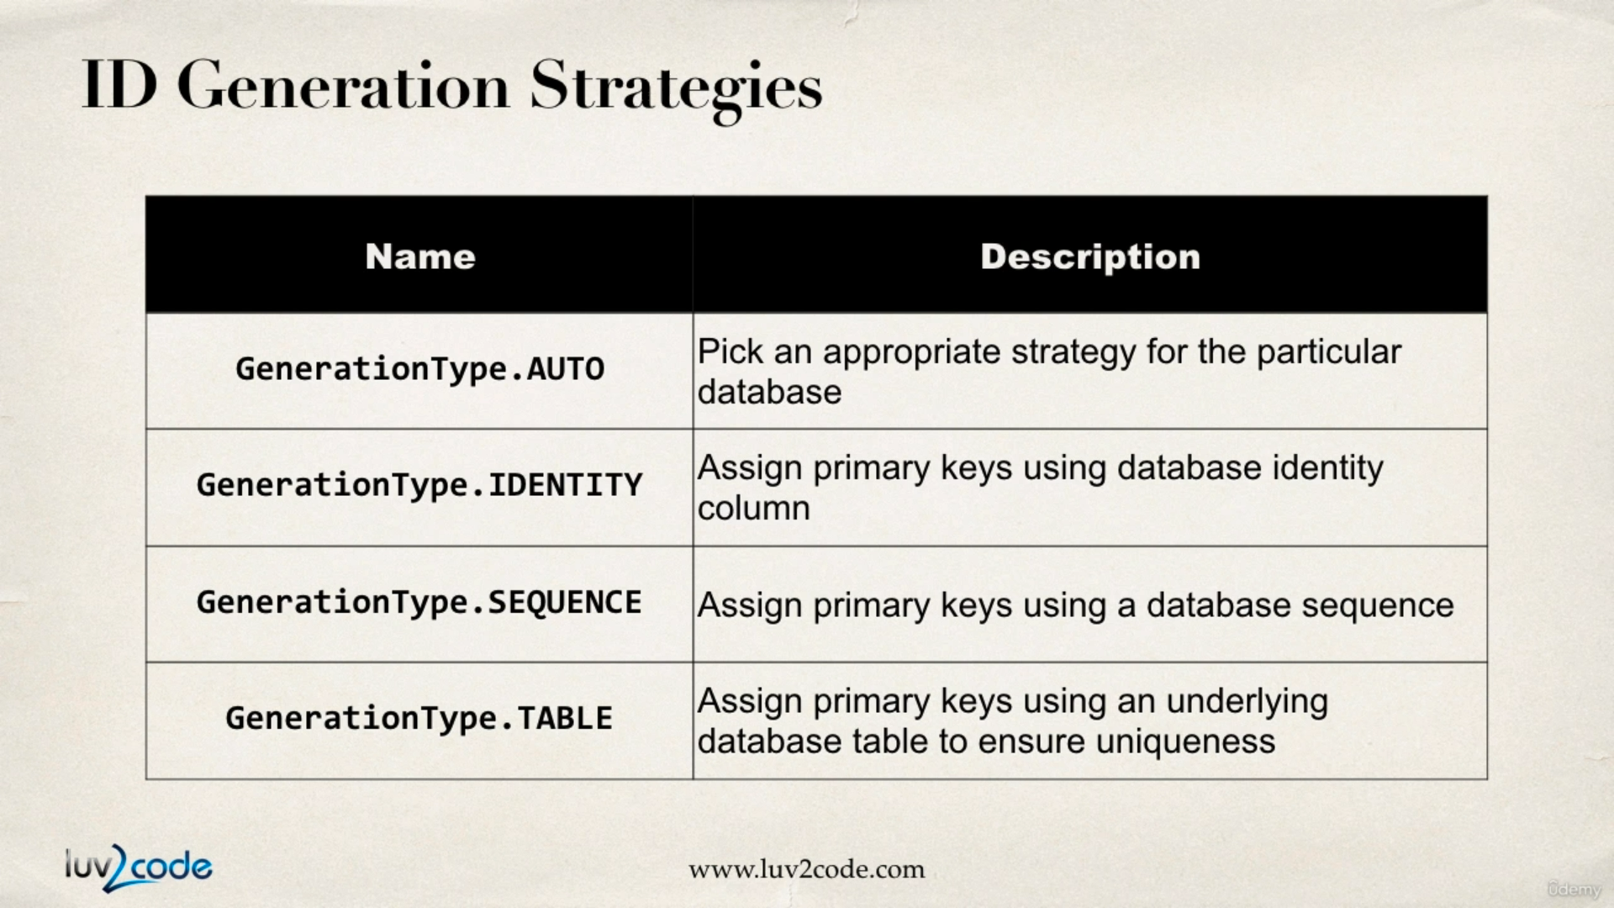

Now there is also a way using which we can provide our custom primary-key generation. We need to implement the IdentifierGenerator and we have to override the method generate().

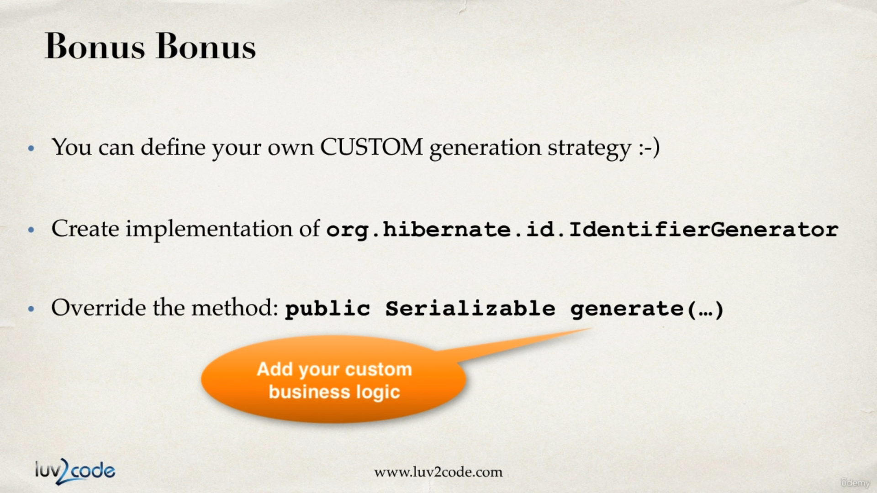

Retrieving Objects with Hibernate

There’s a similar way in which we can retrieve students from the database,

**Student.java (Entity Class)** :

**package** com.hibernate.demo.entity;

**import** javax.persistence.Column;

**import** javax.persistence.Entity;

**import** javax.persistence.GeneratedValue;

**import** javax.persistence.GenerationType;

**import** javax.persistence.Id;

**import** javax.persistence.Table;

@Entity

@Table(name = "student")

**public** **class** Student {

@Id

@GeneratedValue(strategy = GenerationType.***IDENTITY***)

@Column(name = "id")

**private** **int** id;

@Column(name = "first_name")

**private** String firstName;

@Column(name = "last_name")

**private** String lastName;

@Column(name = "email")

**private** String email;

**public** Student() {

**super**();

}

**public** Student(String firstName, String lastName, String email) {

**super**();

**this**.firstName = firstName;

**this**.lastName = lastName;

**this**.email = email;

}

**public** **int** getId() {

**return** id;

}

**public** **void** setId(**int** id) {

**this**.id = id;

}

**public** String getFirstName() {

**return** firstName;

}

**public** **void** setFirstName(String firstName) {

**this**.firstName = firstName;

}

**public** String getLastName() {

**return** lastName;

}

**public** **void** setLastName(String lastName) {

**this**.lastName = lastName;

}

**public** String getEmail() {

**return** email;

}

**public** **void** setEmail(String email) {

**this**.email = email;

}

@Override

**public** String toString() {

**return** "Student [id=" + id + ", firstName=" + firstName + ", lastName=" + lastName + ", email=" + email + "]";

}

}

**HibernateCrud.java** :

**package** com.hibernate.demo.second;

**import** java.util.Scanner;

**import** org.hibernate.Session;

**import** org.hibernate.SessionFactory;

**import** org.hibernate.cfg.Configuration;

**import** com.hibernate.demo.entity.Student;

**public** **class** HibernateCRUD {

**public** **static** **void** main(String[] args) {

SessionFactory sessionFactory = **new** Configuration().configure("hibernate.cfg.xml")

.addAnnotatedClass(Student.**class**).buildSessionFactory();

Session currentSession = sessionFactory.getCurrentSession();

**try** {

System.***out***.println("enter details");

Student student = **new** Student(

**new** Scanner(System.***in***).nextLine(),

**new** Scanner(System.***in***).nextLine(),

**new** Scanner(System.***in***).nextLine()

);

currentSession.beginTransaction();

currentSession.save(student);

currentSession.getTransaction().commit();

System.***out***.println("student saved!! assigned id : " + student.getId());

currentSession = sessionFactory.getCurrentSession();

currentSession.beginTransaction();

Student retrievedStudent = currentSession.get(Student.**class**, student.getId());

System.***out***.println("retrieved student : " + retrievedStudent);

currentSession.getTransaction().commit();

} **catch** (Exception e) {

} **finally** {

sessionFactory.close();

}

}

}

output :

enter details

roopa

kumari

rp@gmail.com

Hibernate: insert into student (email, first_name, last_name) values (?, ?, ?)

student saved!! assigned id : 7

Hibernate: select student0_.id as id1_0_0_, student0_.email as email2_0_0_, student0_.first_name as first_na3_0_0_, student0_.last_name as last_nam4_0_0_ from student student0_ where student0_.id=?

**retrieved student : Student [id=7, firstName=roopa, lastName=kumari, email=rp@gmail.com]**

Querying Objects with Hibernate

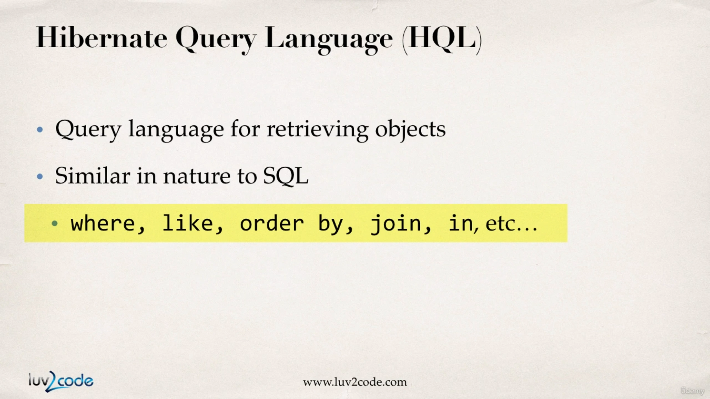

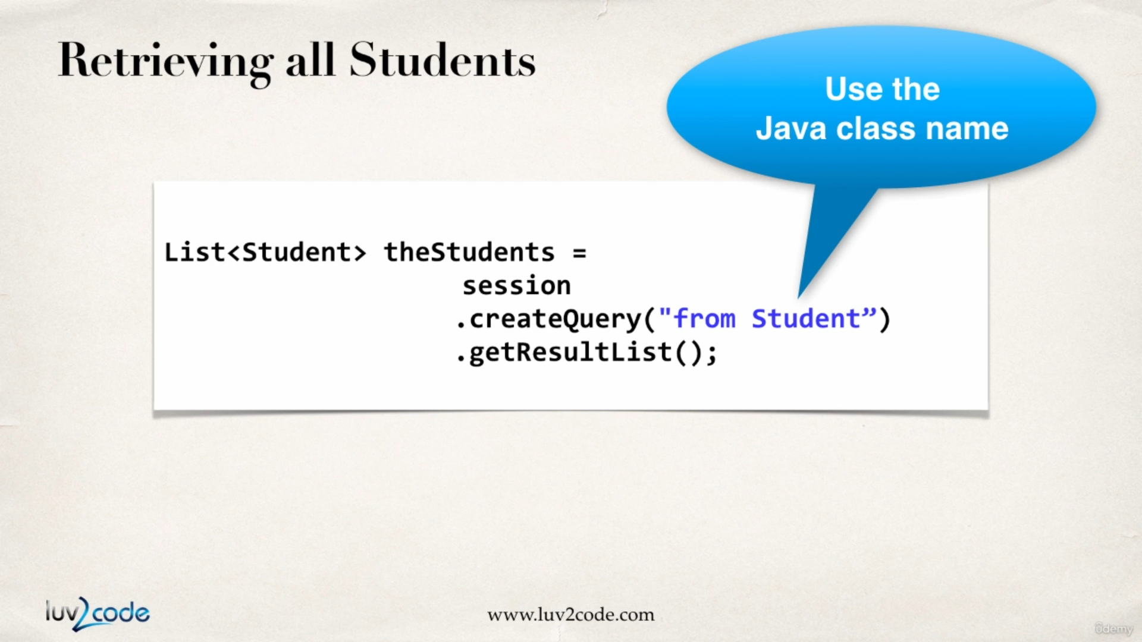

Now consider the code below where we query all the student names from the database. Also in the recent version of hibernate “getResultList()” is changed to “list()”.

**package** com.hibernate.demo.second;

**import** java.util.List;

**import** org.hibernate.Session;

**import** org.hibernate.SessionFactory;

**import** org.hibernate.cfg.Configuration;

**import** com.hibernate.demo.entity.Student;

**public** **class** QueryStudentDemo {

**public** **static** **void** main(String[] args) {

// load hibernate configuration file hibernate.cfg.xml and create an instance of

// SessionFactory

SessionFactory sessionFactory = **new** Configuration().configure("hibernate.cfg.xml")

.addAnnotatedClass(Student.**class**).buildSessionFactory();

**try** {

// get current session object

Session currentSession = sessionFactory.getCurrentSession();

// begin transaction

currentSession.beginTransaction();

List<Student> students = currentSession.createQuery("from Student").list();

// display student list

**for** (Student student : students) {

System.***out***.println(student);

}

// commit transaction

currentSession.getTransaction().commit();

} **catch** (Exception e) {

// **TODO**: handle exception

} **finally** {

sessionFactory.close();

}

}

}

output :

Student [id=1, firstName=Anupam, lastName=Acharya, email=anupam@gmail.com]

Student [id=2, firstName=Anupam, lastName=Sahu, email=sahu@gmail.com]

Student [id=3, firstName=khawja, lastName=ghouse, email=kg@gmail.com]

Student [id=4, firstName=David, lastName=Alex, email=david_alex@gmail.com]

Student [id=5, firstName=Brian, lastName=Cooper, email=cooperbrian@gmail.com]

Student [id=6, firstName=demo-fname, lastName=demo-lname, email=demo-email@gmail.com]

Student [id=7, firstName=roopa, lastName=kumari, email=rp@gmail.com]

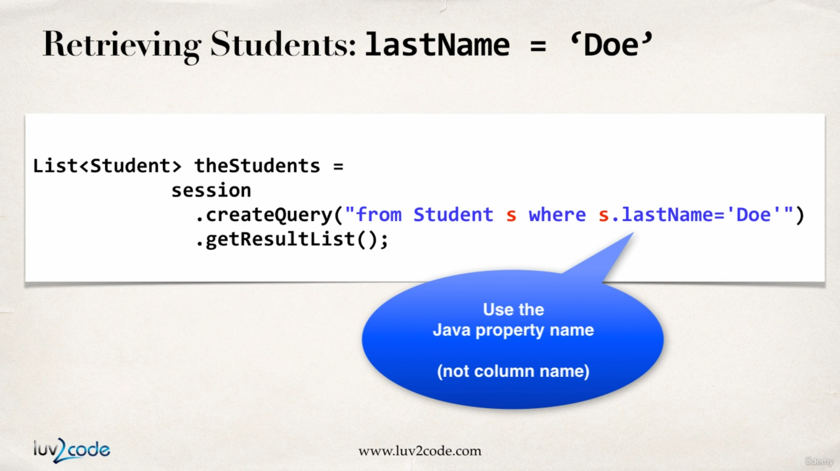

Consider the example below where we print out the students if the last name is ‘sahu’

**package** com.hibernate.demo.second;

**import** java.util.List;

**import** org.hibernate.Session;

**import** org.hibernate.SessionFactory;

**import** org.hibernate.cfg.Configuration;

**import** com.hibernate.demo.entity.Student;

**public** **class** QueryStudentDemo {

**public** **static** **void** main(String[] args) {

// load hibernate configuration file hibernate.cfg.xml and create an instance of

// SessionFactory

SessionFactory sessionFactory = **new** Configuration().configure("hibernate.cfg.xml")

.addAnnotatedClass(Student.**class**).buildSessionFactory();

**try** {

// get current session object

Session currentSession = sessionFactory.getCurrentSession();

// begin transaction

currentSession.beginTransaction();

// fetch students whose last name is 'sahu'

List<Student> resultList = currentSession.createQuery("from Student s where

s.lastName='sahu'").list();

System.***out***.println("displaying students where last name is 'sahu'");

*displayStudents*(resultList);

// commit transaction

currentSession.getTransaction().commit();

} **catch** (Exception e) {

// **TODO**: handle exception

} **finally** {

sessionFactory.close();

}

}

**private** **static** **void** displayStudents(List<Student> students) {

**for** (Student student : students) {

System.***out***.println(student);

}

}

}

output :

Student [id=2, firstName=Anupam, lastName=Sahu, email=sahu@gmail.com]

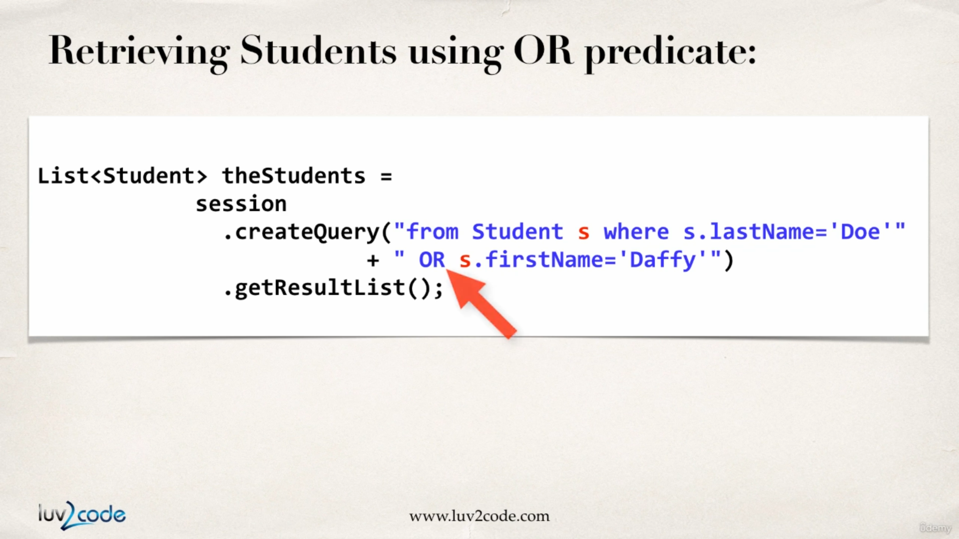

Consider the example below where we fetch the name of students where the firstName is ‘Anupam’ or the lastName is ‘cooper’:

**package** com.hibernate.demo.second;

**import** java.util.List;

**import** org.hibernate.Session;

**import** org.hibernate.SessionFactory;

**import** org.hibernate.cfg.Configuration;

**import** com.hibernate.demo.entity.Student;

**public** **class** QueryStudentDemo {

**public** **static** **void** main(String[] args) {

// load hibernate configuration file hibernate.cfg.xml and create an instance of

// SessionFactory

SessionFactory sessionFactory = **new** Configuration().configure("hibernate.cfg.xml")

.addAnnotatedClass(Student.**class**).buildSessionFactory();

**try** {

// get current session object

Session currentSession = sessionFactory.getCurrentSession();

// begin transaction

currentSession.beginTransaction();

// fetch students whose first name is 'anupam' or last name is 'cooper'

List resultList2 = currentSession.createQuery("from Student s where s.firstName='anupam' or s.lastName='cooper'").getResultList();

System.***out***.println("displaying students where the first name is 'anupam' or last name is 'cooper'");

*displayStudents*(resultList2);

// commit transaction

currentSession.getTransaction().commit();

} **catch** (Exception e) {

// **TODO**: handle exception

} **finally** {

sessionFactory.close();

}

}

**private** **static** **void** displayStudents(List<Student> students) {

**for** (Student student : students) {

System.***out***.println(student);

}

}

}

output :

displaying students where the first name is 'anupam' or last name is 'cooper'

Student [id=1, firstName=Anupam, lastName=Acharya, email=anupam@gmail.com]

Student [id=2, firstName=Anupam, lastName=Sahu, email=sahu@gmail.com]

Student [id=5, firstName=Brian, lastName=Cooper, [email=cooperbrian@gmail.com](mailto:email=cooperbrian@gmail.com)]

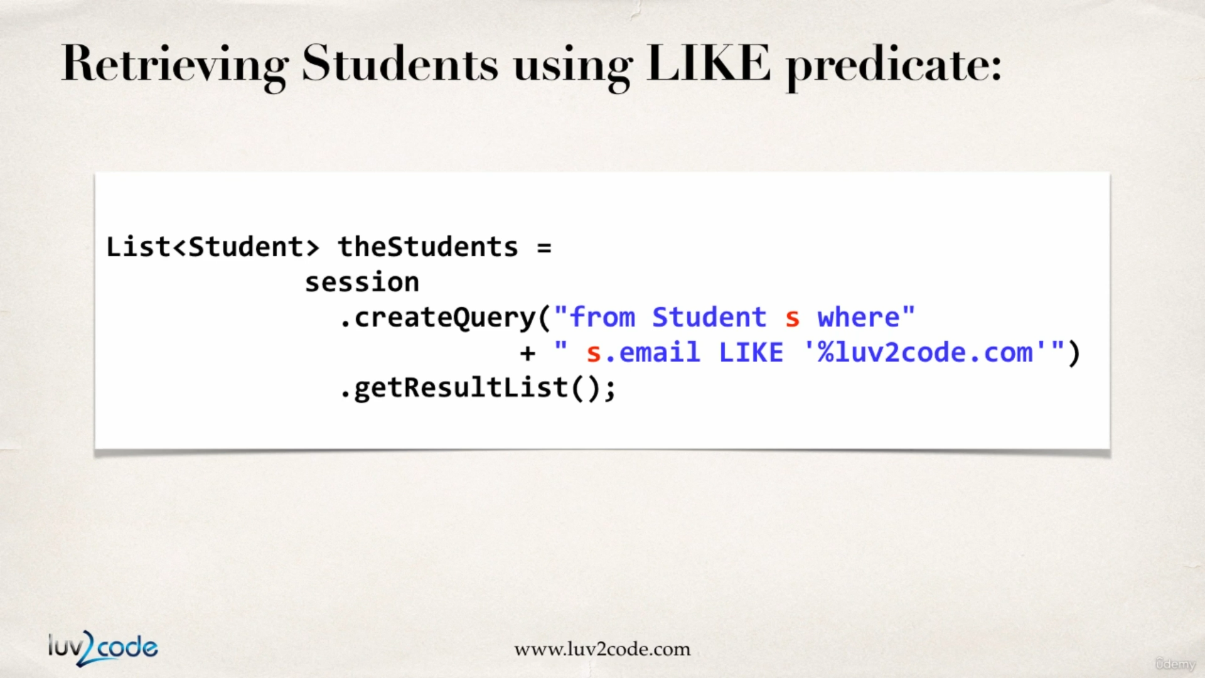

consider the example below where we fetch the students who have ‘demo’ in their email address.

**package** com.hibernate.demo.second;

**import** java.util.List;

**import** org.hibernate.Session;

**import** org.hibernate.SessionFactory;

**import** org.hibernate.cfg.Configuration;

**import** com.hibernate.demo.entity.Student;

**public** **class** QueryStudentDemo {

**public** **static** **void** main(String[] args) {

// load hibernate configuration file hibernate.cfg.xml and create an instance of

// SessionFactory

SessionFactory sessionFactory = **new** Configuration().configure("hibernate.cfg.xml")

.addAnnotatedClass(Student.**class**).buildSessionFactory();

**try** {

// get current session object

Session currentSession = sessionFactory.getCurrentSession();

// begin transaction

currentSession.beginTransaction();

// fetch students whose email id contains 'demo'

List<Student> resultList3 = currentSession.createQuery("from Student s where s.email like '%demo%'").getResultList();

System.***out***.println("displaying students where the email contains 'demo'");

*displayStudents*(resultList3);

// commit transaction

currentSession.getTransaction().commit();

} **catch** (Exception e) {

// **TODO**: handle exception

} **finally** {

sessionFactory.close();

}

}

**private** **static** **void** displayStudents(List<Student> students) {

**for** (Student student : students) {

System.***out***.println(student);

}

}

}

output :

displaying students where the email contains 'demo'

Student [id=6, firstName=demo-fname, lastName=demo-lname, email=demo-email@gmail.com]

Updating Objects with Hibernate

In the example below we will see how can we update a object from a database using hibernate.

**package** com.hibernate.demo.second;

**import** javax.persistence.EntityTransaction;

**import** org.hibernate.Session;

**import** org.hibernate.SessionFactory;

**import** org.hibernate.cfg.Configuration;

**import** com.hibernate.demo.entity.Student;

**public** **class** UpdateStudentDemo {

**public** **static** **void** main(String[] args) {

SessionFactory sessionFactory = **new** Configuration().configure("hibernate.cfg.xml")

.addAnnotatedClass(Student.**class**).buildSessionFactory();

Session currentSession = sessionFactory.getCurrentSession();

**try** {

EntityTransaction transaction = currentSession.beginTransaction();

Student student = currentSession.get(Student.**class**, 1);

student.setEmail("anupamacharya25@gmail.com");

System.***out***.println(student);

transaction.commit();

} **catch** (Exception e) {

// **TODO**: handle exception

} **finally** {

sessionFactory.close();

}

}

}

output:



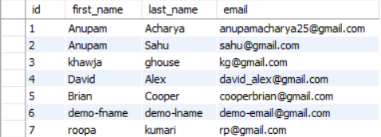

Now in the db table the email id has been modified.

Now from the code we can see we are not calling session.save() or session.update(). This is because when we retrieve an object using session.get(Student.class,1) we get a persistent object.

Whenever we are setting the email using a setter method, the data in the persistent object is modified only in the memory, but when we are doing currentSession.getTransaction().commit() the data is written to the database.

Also along with modifying the single rows in the database we can perform a bulk edit as well, this is shown below :

**package** com.hibernate.demo.second;

**import** javax.persistence.EntityTransaction;

**import** org.hibernate.Session;

**import** org.hibernate.SessionFactory;

**import** org.hibernate.cfg.Configuration;

**import** com.hibernate.demo.entity.Student;

**public** **class** UpdateStudentDemo {

**public** **static** **void** main(String[] args) {

SessionFactory sessionFactory = **new** Configuration().configure("hibernate.cfg.xml")

.addAnnotatedClass(Student.**class**).buildSessionFactory();

**try** {

Session currentSession = sessionFactory.getCurrentSession();

currentSession.beginTransaction();

currentSession.createQuery("update Student set email='foo_bar@gmail.com'").executeUpdate();

currentSession.getTransaction().commit();

} **catch** (Exception e) {

// **TODO**: handle exception

} **finally** {

sessionFactory.close();

}

}

}

output :

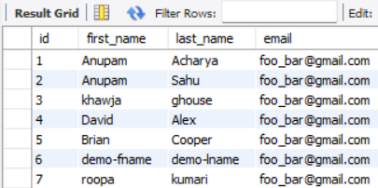

As we can see all the email IDs have been modified.

Deleting Objects with Hibernate